ព្រះរាជាណាចក្រកម្ពុជា

ជាតិ​ សាសនា ព្រះមហាក្សត្រ

Institute of technology of Cambodia

Department of Information and communication Engineering



The lesson taking about basic of array.

TP5-Loop (for loop while loop and do while loop)

TP: Algorithm and Programming

Lecturer: BOU CHANNA

Student: VEN THON

ID: e20191250

Group: I3-GIC-C

Year: 2021-2022

Contents

# Problem1: ………………………………………………………………………………………………3

# Problem2: ………………………………………………………………………………………………4

# Problem3: ………………………………………………………………………………………………5

# Problem4: ………………………………………………………………………………………………6

# Promlem5:……………………………………………………………………………………………..7

Problem1: Write a c program ask user for number and story in an array. Display all number in array.

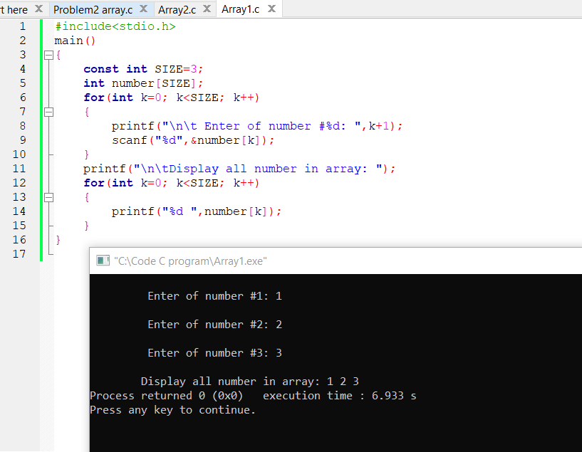

Problem2: Write a c program to stored 7 number in array call a1 created a new array call a2. Make a2 has the data as same as a1(copy a1 to a2). Display number in a2 from back to forth.

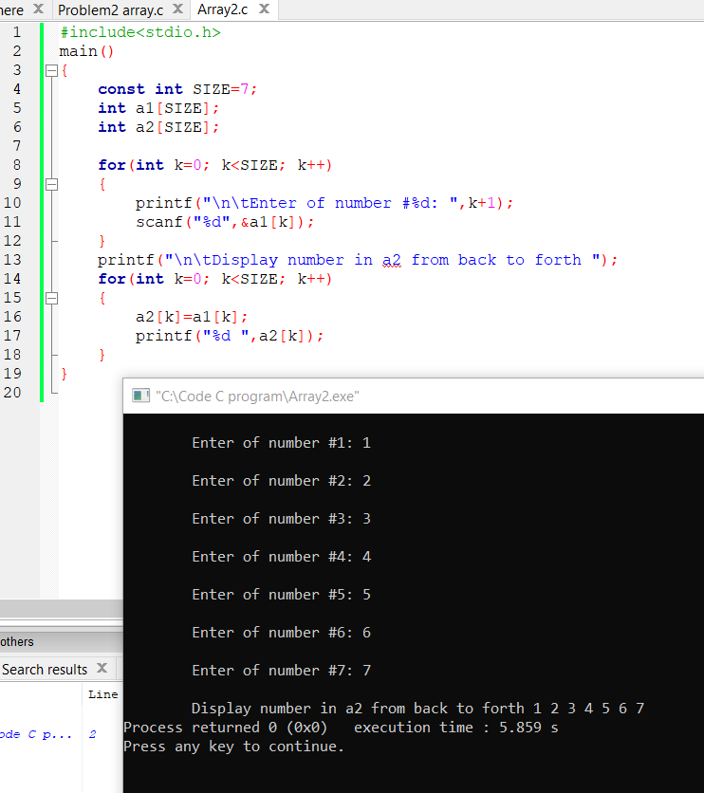

Problem3: Write a c program to store 5 number in an array (ask input from user). Find sum of all number in array and also average. Display all students information on screen.

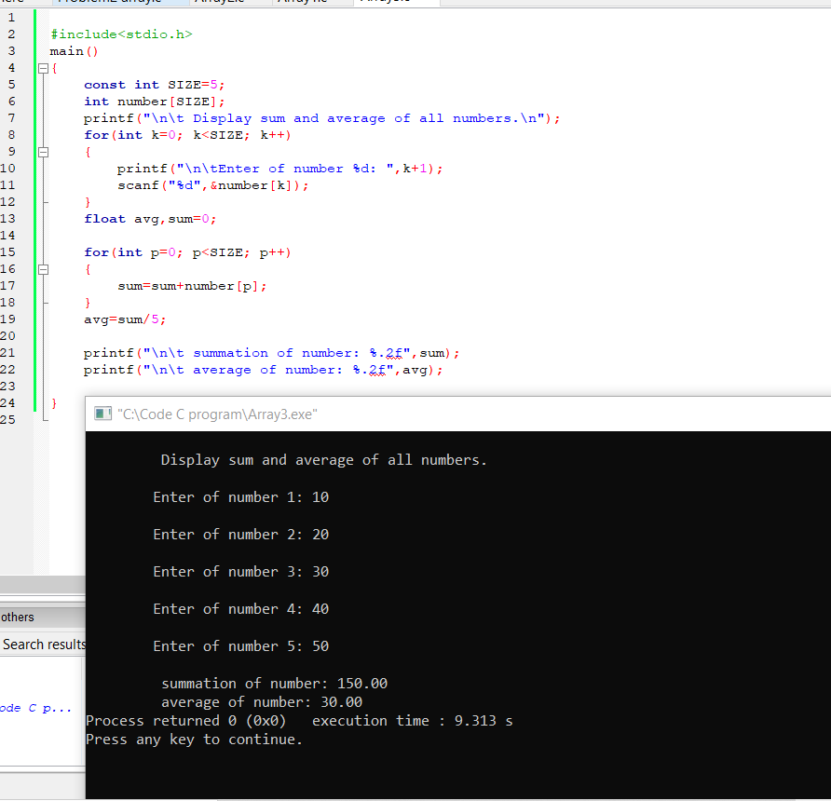

Problem4: Write a program in c to store data of 5 students. Each student has name score email and phone number. The program ask user for information of the 5 students. Display all students information on screen.

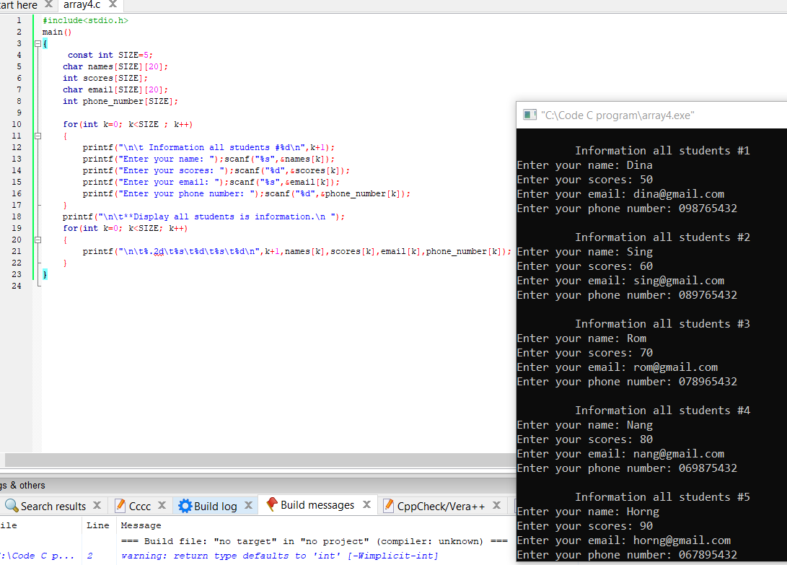

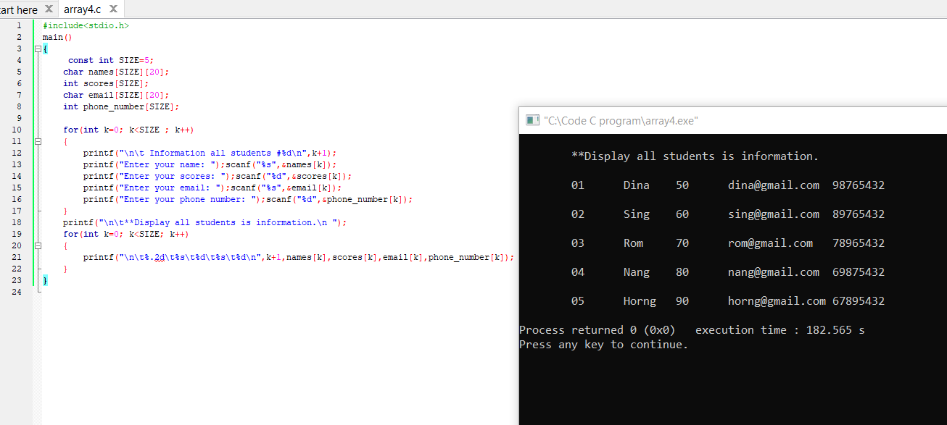

Promlem5: Same as problem#4. Find average score. The program display information of all students who got scores more than average.

